TRADE FINANCE (BIDBOX)

VERSION 1.0

WORKFLOW

1. INTRODUCTION

Trade Finance signifies financing for trade. It concerns both domestic and International trade transactions. A trade requires a seller of goods and services as well as a buyer. Various financial institutions can facilitate these transactions by financing the trade.

In our Trade Finance demo application, we are taking in to account LPO Finance in particular. This is where a bank finances a client to supply goods and services to a known buyer mostly when it comes to tenders. We have 4 main key players within BidBox which include: Fintech Kenya LTD (who will be the owner of BidBox), Banks, Suppliers (sellers) and finally the buyers.

We have taken the necessary measures to ensure that every entity only access the pages of which they have access rights to. We have used set roles which are MasterAdmin, CompanyAdmin, CompanyUser, BankAdmin, BankUsers and Individual. Below are the processes to be followed when using BidBox.

1. Login

To start the application use <http://bidbox.azurewebsites.net/> URL. A home page appears with an option to login to the system.



Click on Login and use [eng.christhuku@gmail.com](mailto:eng.christhuku@gmail.com) as the username and 8L_?ry3M as the password. This credentials let you login as the master admin of the system.

Once you have successfully logged in, you are provided with a dashboard with the following modules.

1. BIDBOX PROCESSES ACCORDING TO USER ROLES

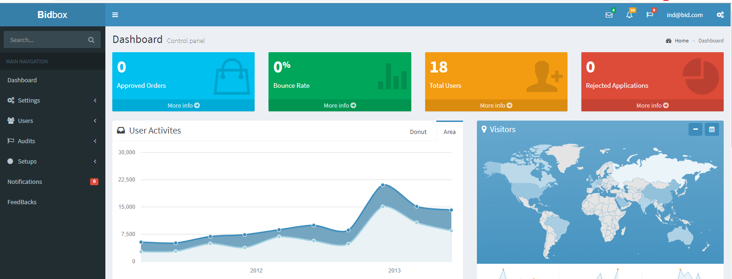

1. Master Admin

The master admin has the rights to add a new company under settings module. Once a new company is added, he/she can go ahead and add a company user. The company user added by the master admin becomes the company administrator with the role of companyadmin.

The master admin as well adds the system banks and thereafter can add a bank user. The bank user becomes the bank admin of the specified bank. The master admin also has the rights to view all the individuals who have registered to the system and also configures all the system setups which include currencies, system parameters etc

1. Company Admin

The main task of the company administrator is to add company users and to view the applications as they come in. The statuses of the applications made by the company users give the company admin a visual representation of all the approved and pending applications.

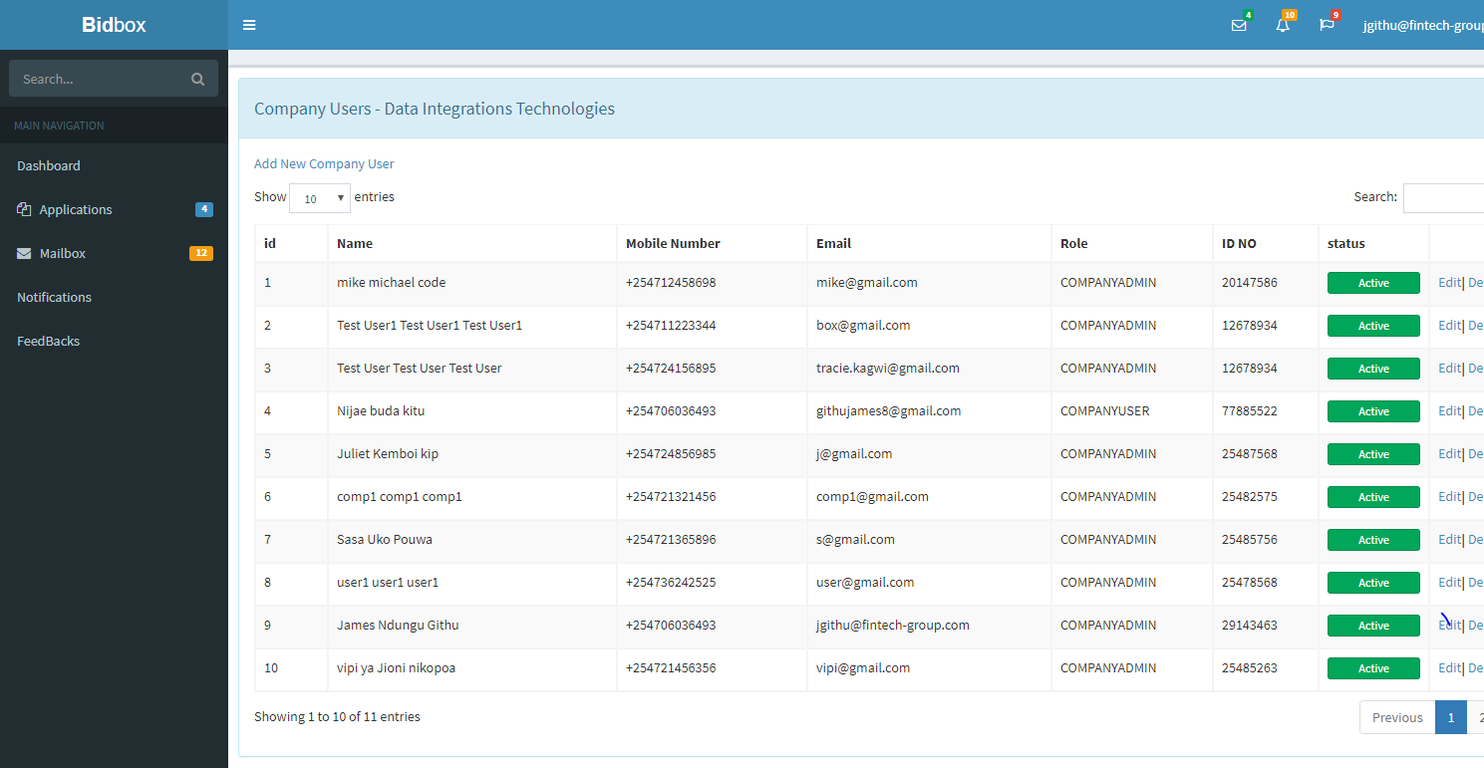

1. Company User

When a company user is created, an email is sent to him for confirmation. He/she can now log into the system and enjoy the services offered. BidBox offers a platform for application of financial help by a specific bank as preferred by the company user.

The application process starts with the company user selecting the preferred bank of choice. Every bank has its own set of commission matrices that are determined by the range of amount you would like the bank to finance you with. Once a bank has been selected, the user inputs the amount and then selects a currency. The commission is auto computed. The users will then go ahead and fill the rest of the fields as required. Once that is done, the bank will require the user to upload some documents, where some could be mandatory while others could be optional to facilitate a smooth transition of the approval and verification process.

Once the application has been saved the user will have to wait for the approval process to be done by the bank user so that he can have an option to finally check out and proceed with the payments

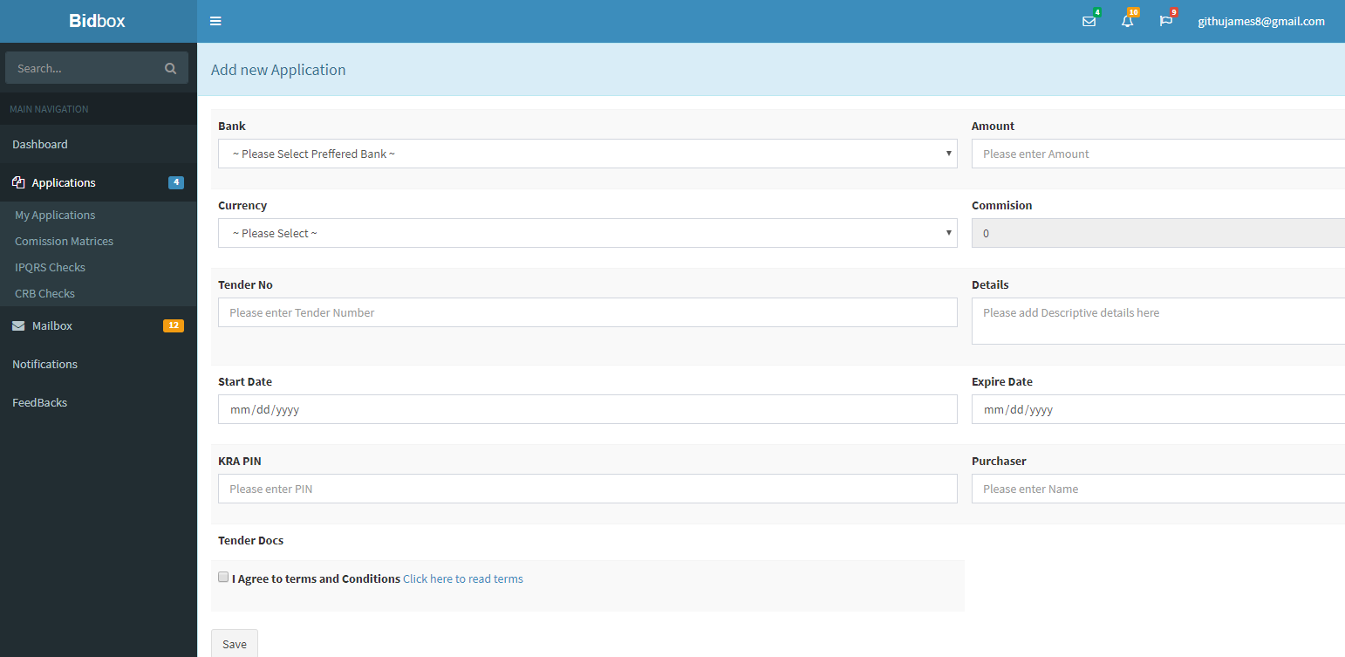

1. Bank Admin

The bank administrator is responsible for maintaining all the bank details as well as the bank users. He also has the mandate to set up the bank commission matrices and also the documents required when a company user or an individual (will talk about his roles below) makes an application through the bank. Below is a diagram showing the modules accessible by the Bank Administrator

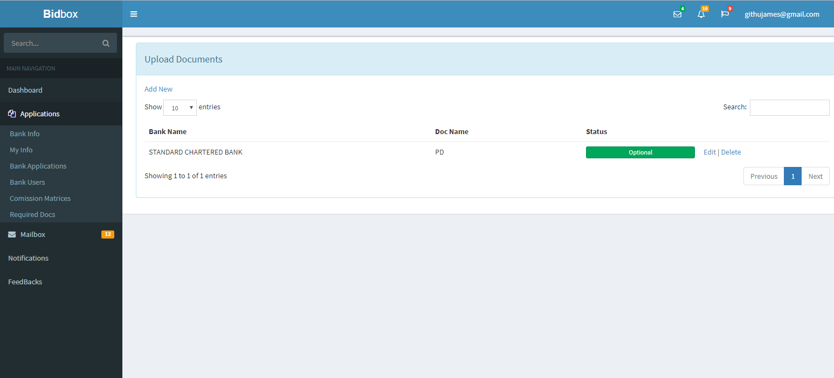

1. Bank User

The main role of a bank user is to verify the applications done by the company user and an individual. Remember bank users are added by the bank administrator. When a bank user logs in to the system he/she is able to see the applications made through the bank. To view the applications click on Applications module then bank applications. Below is a diagram showing the applications.

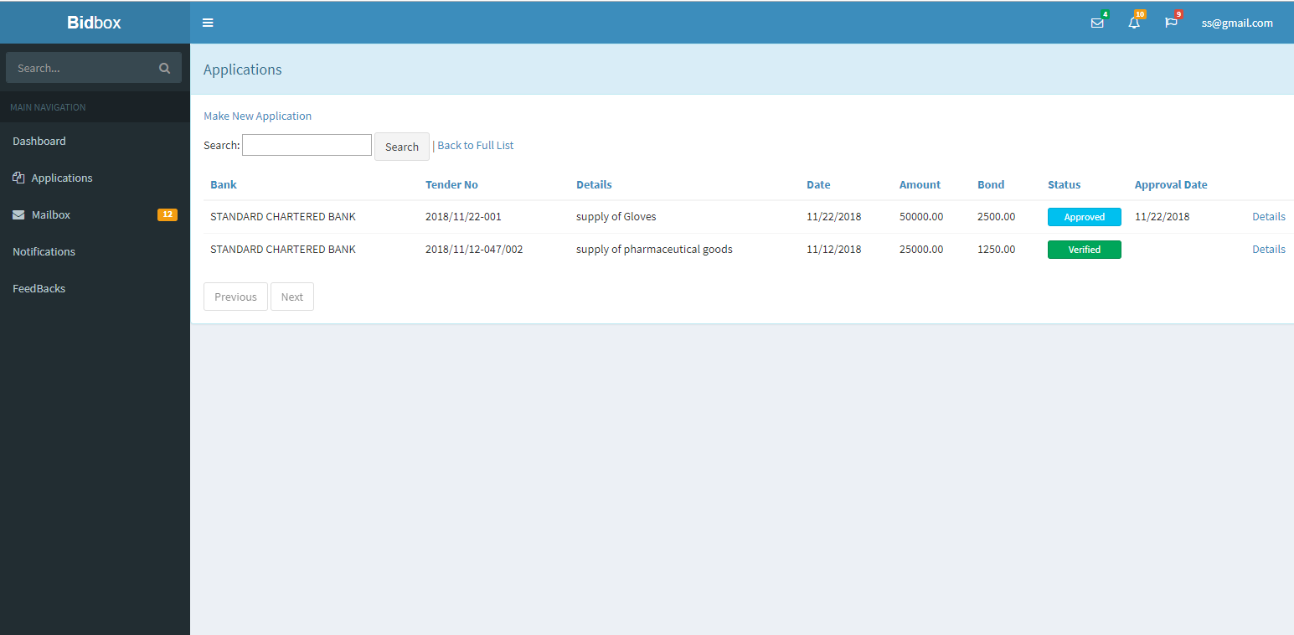

There are 2 approval levels. Once the first approval process has been done the status will change to approved and once the second approval has been done the status will change to verified. To approve or reject an application, click on Details link which is on the far end of the applications list. This will display such a screen.

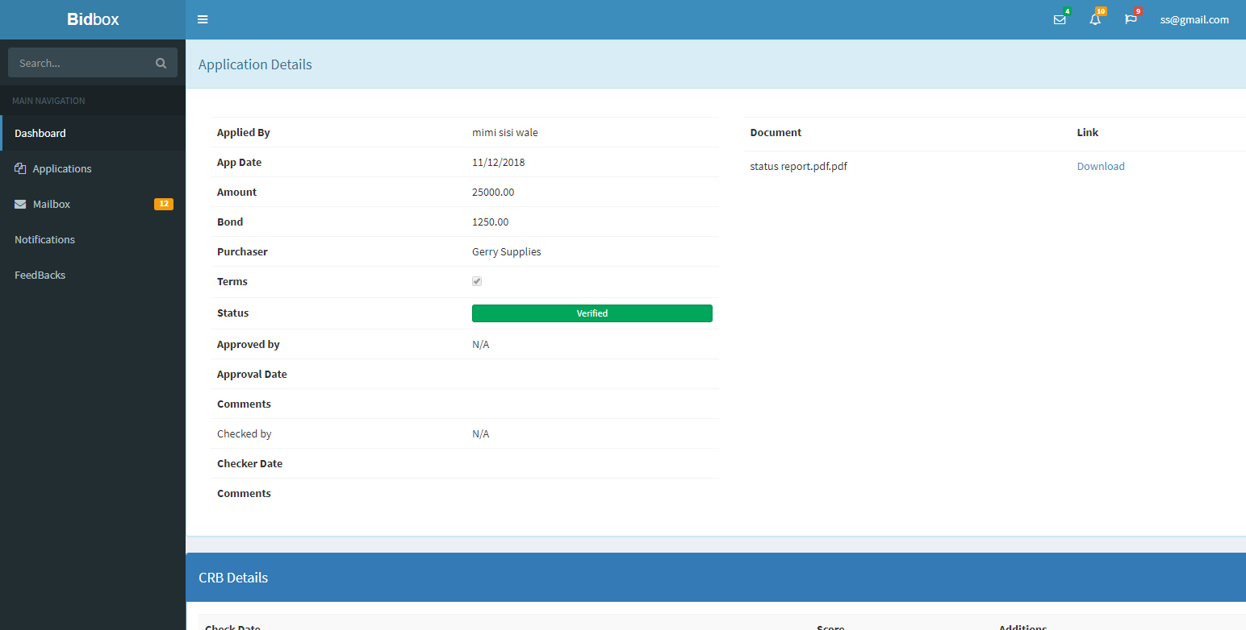

You will get all the details of the application as well as an option to download the documents uploaded by the applicant for verification. The after you add a comment then click approve or reject.

1. Individual

This is the normal user who wants to get the financial services from the bank of his choice.

The first process is to register in to the system. To achieve this, on the home page, click on register and a pop up page will appear with fields that the applicant will have to fill.

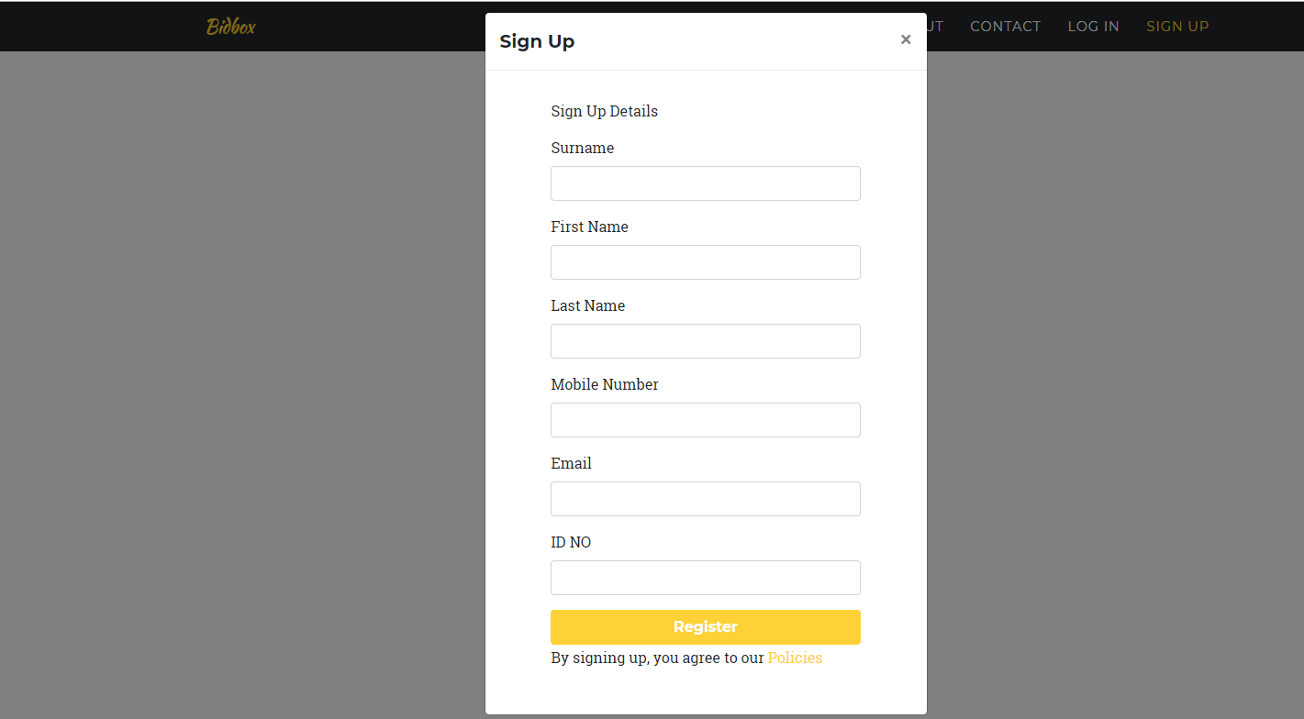

Upon registering, the user will receive 2 email notifications. One will provide a password to login to the system while the other will give a link to verify your email address. When the verification has been done, the user can now login to BidBox and enjoy the services.

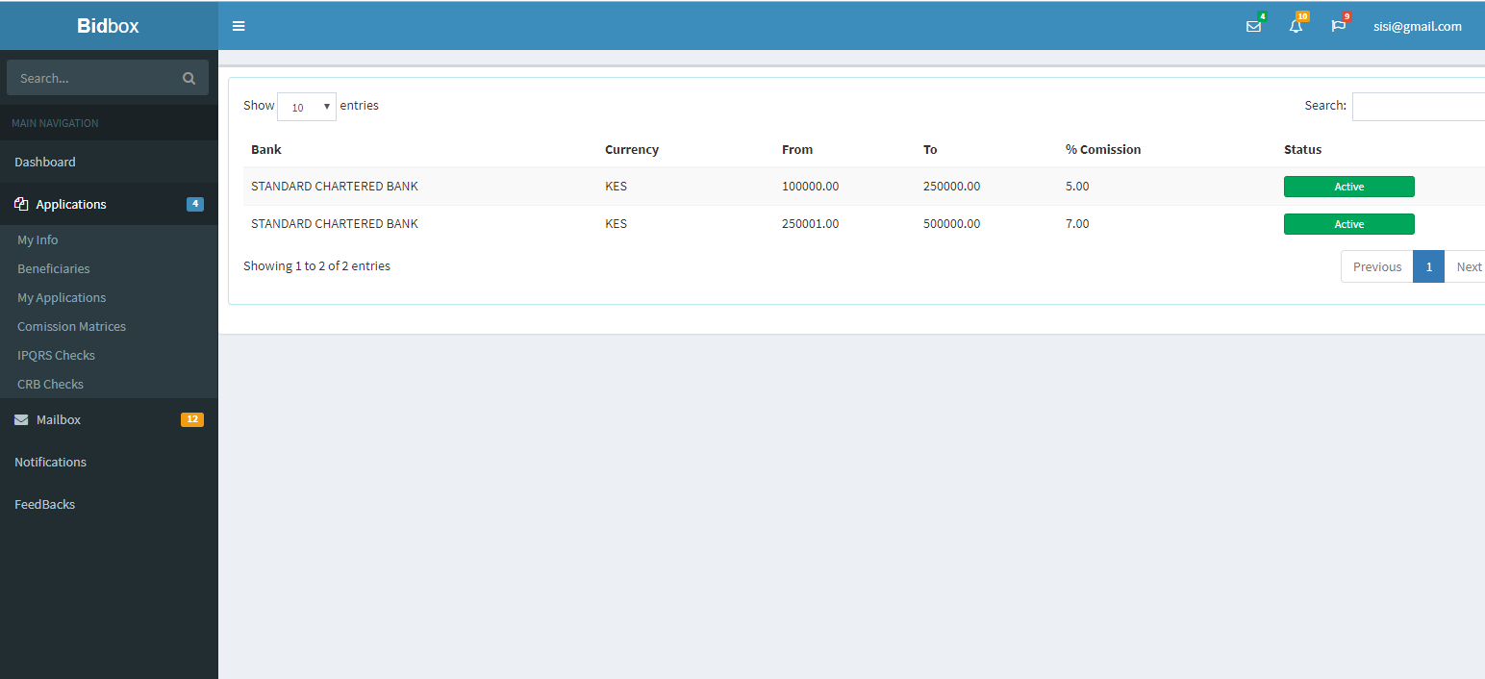

Upon successful login, the user is given the role to view the banks commission matrices. This will guide the user when making an application. The application will be similar to that of a company user which will follow the same process till payments. The difference between an individual and a company user is that, a company would also wish to seek financial services from a bank. But in this case, there has to be the person responsible for the company itself that’s why we have the option of company users.

Those are the key user roles we have in BidBox. For the purpose of our Oracle Block Chain pilot test, I’ll highlight the following:

* We will have 4 nodes within the application. That is, Fintech (who will be the owners of BidBox), Banks (Who will be offering the financial services), Suppliers (this are the people or companies seeking the financial services) and Buyers (This module is not complete yet. We will have it live soon)
* Below will be all the conditions that need to be met before any transaction is posted. And in this case transaction referring to any data that is saved in the database.
* Later on will be a flow chart showing the process flow of what we have in BidBox.

1. CONDITIONS

The conditions will be grouped in terms of modules so as to ease the process flow.

1. Login

* Provide a valid email address and a valid password to be able to access the dashboard.

1. Registration

* For a successful registration, fill all the fields and make sure you use an email address that you hadn’t used before. If you use an already existing email address, you will get the following error, Email Address already used.
* The phone number must be valid.
* All fields are required.
* All users are automatically assigned their roles during registration according to who is doing the registration
* System parameters need to have been set to allow email notifications.

1. Settings

* While adding a new company apart from physical location, all the other fields are mandatory
* When adding new company admin, don’t use an already existing email address. The transaction won’t go through.
* The same applies when adding a new system bank. All fields are mandatory. Don’t use an existing email address for a new bank admin.

1. Setups

* In this module, we have several sub modules. All fields are mandatory and valid data should be used when making a new transaction.
* Under sys configs, which are the system configuration parameters, there is an option for status. The value of this field should either be 0 or 1

1. Applications

* Commission matrices need to have been set before an application is done.
* Only a user having company user role or individual role has the right to make an application.
* All mandatory documents have to be uploaded.
* The start date cannot be greater than the end date.
* Terms and conditions must be accepted to allow a successful application
* The amount must be valid.
* The bond start date cannot be less that today
* During applications approval, only a user with the role of a bank user has the access to approve or reject an application.
* One bank user cannot approve the same application twice. That is when the user approves the first time, another bank user logins in to complete the verification.
* On Commission matrices, the range of values given should be different from what is already saved for that particular bank. Failure to which, there will be an override of values.

1. FlowChart

Below is a flowchart diagram showing the process flow of BidBox application.

CREATES A COMPANY ADMIN

CREATES A COMPANY

FINTECH

BANK USER 1VERIFIES APPLICATION

CREATES A BANK USER

CREATES A BANK ADMIN

CREATES A BANK

USER MAKES APPLICATION

CREATES A COMPANY USER

Register Individual

VERIFY

success

APPLICATION REJEJCTED

Rejected

Approved

PROCESS PAYMENTS

PAYMENTS

CHECKOUT

APPLICATION REJEJCTED

BANK USER 2VERIFIES APPLICATION

NO Yes